Open in app or online

The sadists of Treblinka

22nd June 1943: Amongst the unspeakable horrors of one of the Nazi centers for mass murder the SS torment and torture the forced laborers
JUN 22

SHARE

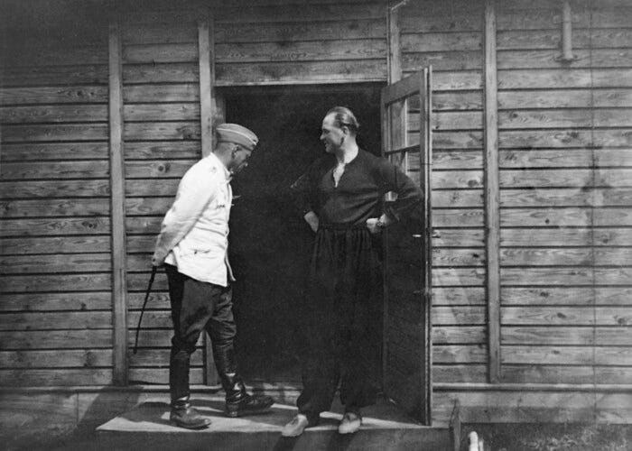
Franz Stangl (1908-1971) the commandant of Treblinka, with a whip, and his deputy Kurt Franz (1914-1998) at the entrance to one of Treblinka’s staff residences – built in Tyrolean style.
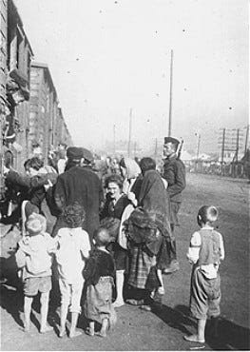
Under guard, Jewish men, women, and children board a train during deportation from Siedlce to the Treblinka killing center. Siedlce, Poland, August 1942.
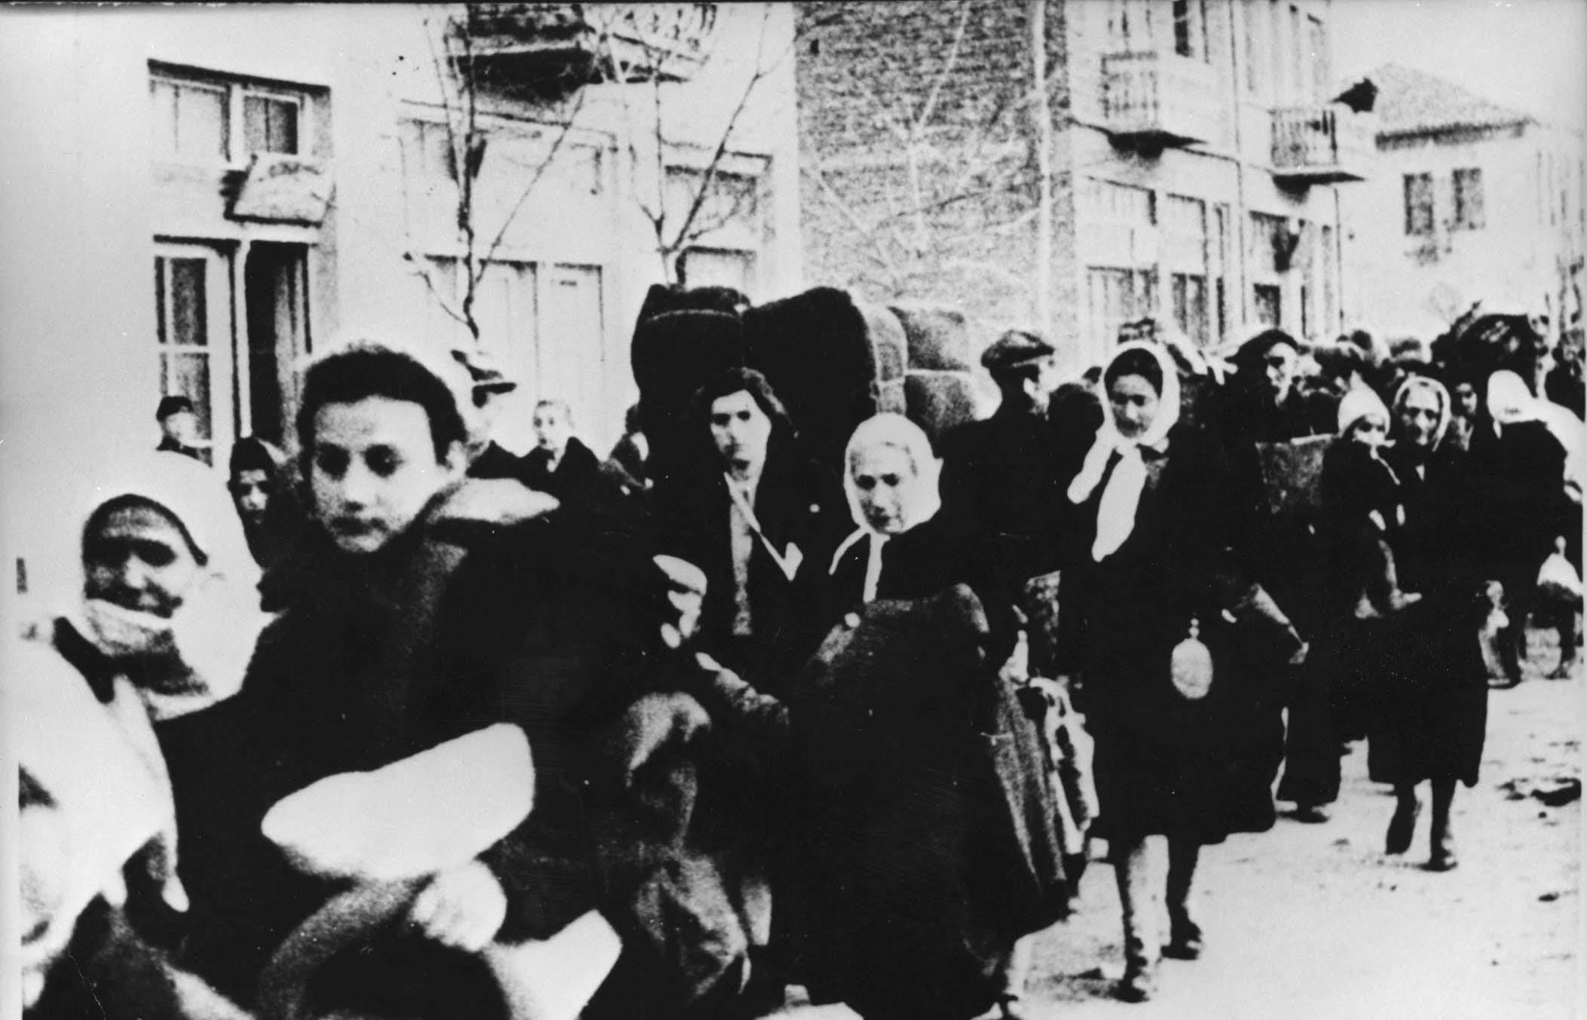
In addition to the main programme to exterminate the Jews of Poland, Treblinka also took some Jews from around Europe. Jews being deported from Macedonia to the Treblinka Death Camp, March 1943
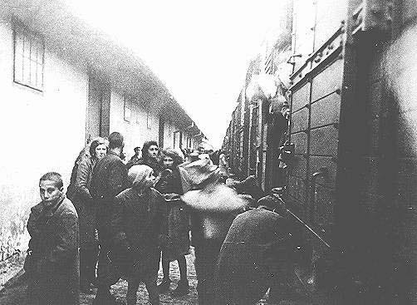
Macedonian Jews prepare to board a deportation train in Skopje. Skopje, Yugoslavia, March 1943. An estimated 925,000 Jews, as well as an unknown number of Poles, Roma, and Soviet POWs, were murdered in Treblinka.
In Treblinka, one of the principal death 'camps' that were being used to exterminate the Jews of Poland, a number of Jews were temporarily reprieved. A few hundred were diverted from the gas chambers to work, in the most appalling conditions, on the disposal of the bodies and the sorting of personal possessions. At first, the SS had periodically killed these workers and taken new 'recruits' from the arriving transports. But it became too troublesome to train the new workers constantly. It was for this reason that some of the forced laborers survived for more than a few months.
These men remained constantly at risk of summary execution if they deviated from the SS routine and could be murdered at random just for the amusement of the guards.
Chil Rajchman¹ was employed to remove the gold teeth from the corpses of those who had been gassed. He had been in the camp long enough to witness the sadistic practices of the guards in the depths of winter. Now he saw them in action during the summer:
It was a hot day. Several staff members had returned to the camp who had gone on leave a fortnight earlier, though every one of these bandits receives twenty-four days of leave every six weeks because of their strenuous “work”. While on leave, they had dressed in civilian clothes and left their sacred uniforms in the camp. When they came back from their Erholung (recuperation) they were constantly in a bad mood.
We once overheard a conversation in which one of them told the other that the city he comes from was being bombed day and night and that there were many casualties from air raids.
We also notice that the murderers, coming back from leave, don't look good. It appears that the care they get at home is not as good as what they get in Treblinka. Here, in Treblinka, they can afford everything, since there is no lack of money. After all, every victim that arrives in Treblinka has managed to bring something with them.
It is a very difficult day today. S.S. Unterscharfuhrer Chanke — we call him “The Whip" because he is a specialist in beating — is in a bad mood. His comrade Unterscharfuhrer Loefer is no small sadist himself. He has terrifying eyes, and all of us are afraid that his glance will fall on us because in that case we are done for. Despite the fact that they are tired from their journey, they beat us mercilessly.
Ivan is about twenty years old and looks like a giant healthy horse. He is pleased when he has an opportunity to let off his energy on the workers. From time to time he feels the urge to take a sharp knife, detain a worker who is running past and cut off his ear.
I remember a case in which two workers forgot themselves and placed the corpses of three small children on the litter instead of one adult corpse. Unterscharfuhrer Loefer detained them, raining blows down on them from his whip and screamed: — You dogs, why are you carrying trinkets? (“Trinkets” is what they called little children.) The “trinket”-bearers had to run back and collect an adult corpse.
On such a hot day the Ukrainian henchmen feel very good. They work left and right with their whips. Mikolai and Ivan, who work as mechanics on the motor that sends the gas into the chambers and also work on the generator that provides electric lighting for Treblinka, feel happy and in splendid shape in such weather.
Ivan is about twenty years old and looks like a giant healthy horse. He is pleased when he has an opportunity to let off his energy on the workers. From time to time he feels the urge to take a sharp knife, detain a worker who is running past and cut off his ear. The blood spurts, the worker screams, but he must keep running with his litter. Ivan waits calmly until the worker runs back and orders him to put the litter down. He then tells him to strip and go over to the pit, where he shoots him.
Ivan once came over to the well where I and another dentist called Finkelstein were washing teeth. Ivan was carrying an auger. He ordered Finkelstein to lie down on the ground and drilled the iron tool into his buttocks. That was meant to be a joke. The wretched victim did not even scream, only groaned. Ivan laughed and shouted repeatedly: - Lie still, otherwise I'll shoot you!
..
After the episode with Loefer, Finkelstein had to get up and go back to work. He was a healthy young man. At the first opportunity Dr Zimmermann took him into his room and washed and bandaged his wound. The wound healed; Finkelstein survived till the revolt.
1
Chil Rajchman: Treblinka

